**Backend (admin section): POT**

1. This is how it looks now:  
   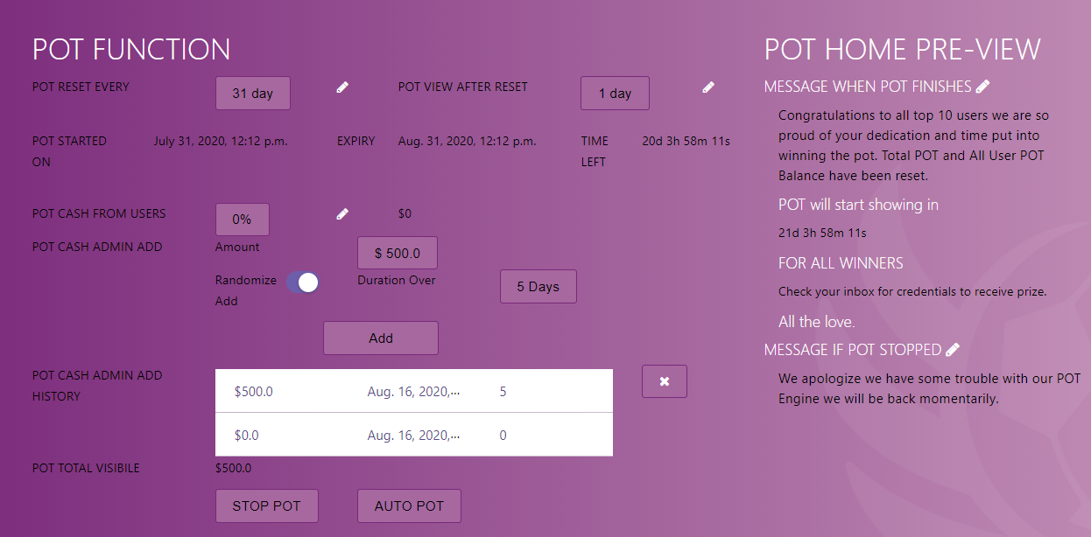

Vs how it should be: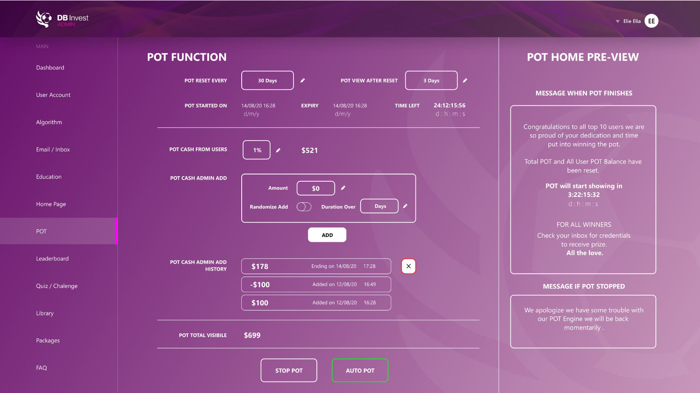

1. “Pot cash from users”:   
   Admins will chose a percentage from total users’ subscription.  
   So 1% means 1% from total users subscription
2. “Pot cash admin add”:

We are not expecting to start with 10000 users, so in the beginning we will be adding manually some money to the pot, to engage users

1. So total visible pot will be sum of “pot cash from users” and “pot cash from admin”

